1. Initiate app and display Item ID, Product Name, and Price.

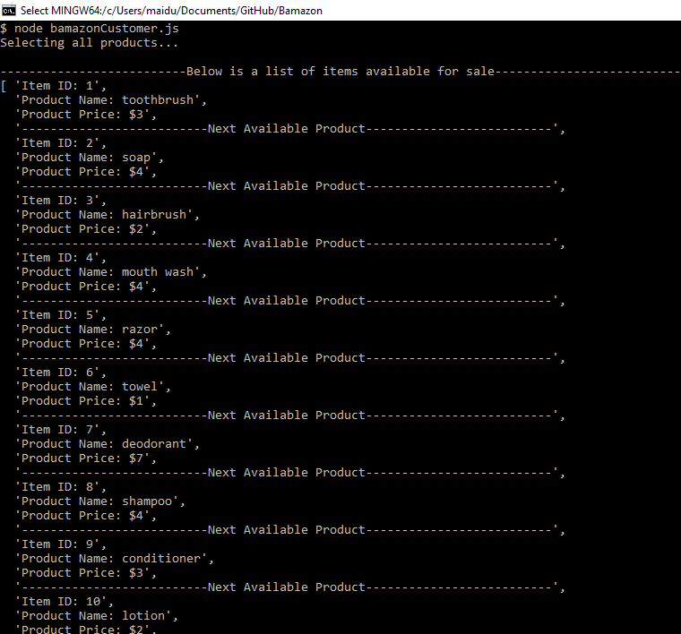

2. Prompts for the product, quantity the customer would like, and total owed:

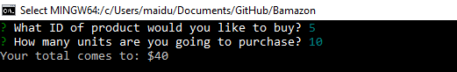

3. If the quantity exceeds the stock amount, error message:

